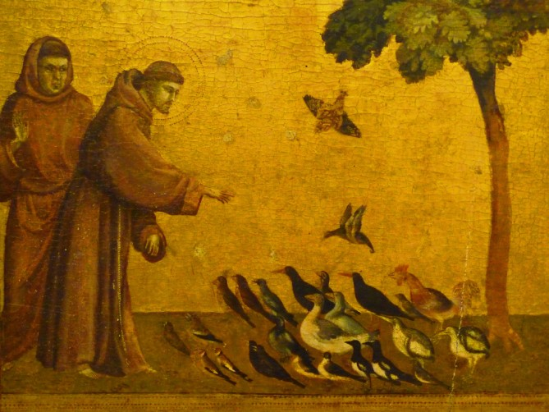

IMMACULATE CONCEPTION CATHOLIC CHURCH
506 COUNTY ROAD 1 - WEDOWEE, AL 36278
October 4, 2026
27th. Sunday in Ordinary Time
Reverend Gali Balaswamy gbalaswamy10@gmail.com 334-497-4847
Mass Times: Sunday English 10:30 am
Spanish: 12:00 pm
Friday Mass: Spanish: 6:00 pm
Sacrament of Reconciliation: Friday’s at 5:00 pm
Sunday’s at 11:30 am
Contact Information: Parish office: 256-357-2977
Email: immaculateconceptional@gmail.com
Website: Immaculateconceptional.org
Facebook: Immaculate Conception Catholic Church

Mission Statement: To enable ourselves and others to know, love and serve God the Father, Son and Holy Spirit. To participate in and provide the Sacraments. To promote spiritual growth and religious education and fellowship of the Catholic Church to all. To utilize the talents, leadership qualities and special skills given to us as a diversified parish family and to promote unity and develop closer relationships with other Christian faiths.

Pope's October Prayer Intention For Mental Health Ministry -- Let us pray that the mental health ministry be established throughout the Church, helping to overcome the stigma and discrimination of persons with mental illnesses.

Weekly Mass Attendance: English 74 Spanish 156
Weekly Offerings
Weekly Collection: $ 1,647
Weekly Online $ $ 1,460 Catholic Charities $840
Building Fund: $ 461
Building Online: $ 132


ONLINE GIVING IS NOW AVAILABLE AT IMMACULATE CONCEPTION. Text to give is now available at Immaculate Conception. Just text the word “give” to 256-330-5544 and follow the links to set up a one time or recurring donation. Choose your convenient way to contribute either by text, online link https://giving.parishsoft.com/app/giving/icwedowee or QR Code Why not set up your recurring donation today and forget about writing checks. If anyone has any questions or needs help concerning any online giving options, feel free to contact Gerry Gettinger. 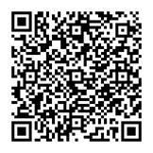
ST. BLAISE HALL is available for small gatherings. Anyone wishing to use the hall for any reason MUST HAVE THEIR GATHERING PUT ON THE CHURCH CALENDAR. Contact Michele at variscom506@gmail.com or 678-481-0529
PRAY FOR THE SICK –Jim Betts, Ian Buchanan, Shirley & George Cervosky, Sarah Daly, Rita Agnes, Clay Stiner, Terri Dramis, Brent Hansen, Douglas Reiland, Dee Lohr
GUIDELINES FOR RECEPTION OF SACRAMENTS
BAPTISM: Contact Fredy Valasquez. He will set the date for Classes and confer with Fr Bala for a Baptismal Date. A minimum of 30 days, notice and completion of Baptismal preparation class and documentation must be completed before a date may be set.
MARRIAGE: Anyone planning a wedding must first contact Fr Bala. The guidelines set by the Diocese of B’ham state that one must contact the Pastor a minimum of 6 months prior to the selection of a date for the marriage. There are no exceptions.

FIRST HOLY COMMUNION: The youth must be in the second grade, older, and actively engaged in PSR for 2 or more years.
CONFIRMATION: The individual must be in the 7th grade, or older, and actively engaged in a two-year Confirmation preparation program.
QUINCEANERA: Individuals must contact Fr Bala at least 6 months prior to setting a date and begin a time of preparation to fully understand the significance of the celebration. There are no exceptions.

PARISH NEWS:

October is the MONTH OF MARY. We will be praying the rosary each Sunday this month starting at 10:10. Please plan to come to church a little early to pray with us.

Next Sunday, October 4, is the feast of St. Francis. Francis was a wealthy man of privilege, served as a soldier and was a prisoner of war. He heard God’s call and went on to be one of the most venerated Catholic Saints. He was the first man ever recorded to receive the stigmata, the wounds of Christ. He is the patron saint of animals, ecology and the environment. Pope Leo has dedicated this year to honor St. Francis

RANDOLPH COUNTY ANIMAL SHELTER Fall Book Sale is October 3 & 17, 9a.m. to 1 p.m. at the Old Cotton Warehouse on Main Street in Roanoke across from the old Randolph Leader office. Hardbacks $2, Paperbacks, $1 and Children's 3/$1

Cornerstone Catholic Scripture Study begins on Monday September 28th at 6:30pm via zoom. If you are interested in joining please contact Michelle Hunt at cantex1@sbcglobal.net or 936-242-9496

OCTOBER LUNCHEON Sunday October 4th- The theme is “Autumn Harvest". An Email will be sent out soon with more details.

FOOD PANTRY If you would like to donate food to the Immaculate Conception Food Pantry, there is a list of needed items in the pantry. Monetary donations may also be made. Please remember that if you need food, whether you are Immaculate Conception parishioner or not, please contact Elvira Allende, 256 914-9645

DIOCESE NEWS
WORLD MISSION SUNDAY - OCTOBER 18 -- This year's theme is ONE IN CHRIST, UNITED IN MISSION, chosen by Pope Leo XIV. This appeal invites us to rediscover the profound unity we share in Christ through the sacraments of initiation and how that Christian identity is meant to overflow into personal involvement to bring all peoples into communion with Jesus. Please be generous and help missionaries everywhere!.

PASTORAL MINISTRIES
Reverend Bala Balaswamy
Michele Varisco: Parish Council Chairperson
Email: variscom506@gmail.com Cell (678) 481-0529
Finance Council Chair: Jim Mitchell 678-717-7441 jtmitchell94@gmail.com
Hispanic Liaison: Exequiel Perez 256-276-8695

Sacristan: Alison & Nawana

OCTOBER MINISTERS SCHEDULE
Sunday, October 4 Lector: Charlotte Announce: Gerry
E.M. Pat
Usher: Tom & Frank
Sunday, October 11 Lector: Bart Announce: Brett
E.M. Helen
Usher: Tommy & Roger

Sunday, October 18 Lector: Evelyn Announce: Charlotte
E.M. Tommy
Usher: Paul & Frank
Sunday, October 25 Lector: Brett Announce: Evelyn
E.M. Gerry
Usher: Roger & Tommy

Altar Linens 2026
October Sandra
November Alison
December Bernardina

Church Cleaning Schedule:

Oct 3 – Pastor Lucero Group
Oct – 17 Fussell & Varisco
Oct 31 - Benedicto Gomez & Group
Nov 14 – Horacia/Bernadina & Baldomer/Hilaria
Nov 28 – Vincente/Elvira & Jose/Sandra
Dec. 12 -- Anker/Burke/Mitchell
Dec. 26 -- Maguis/Flores

