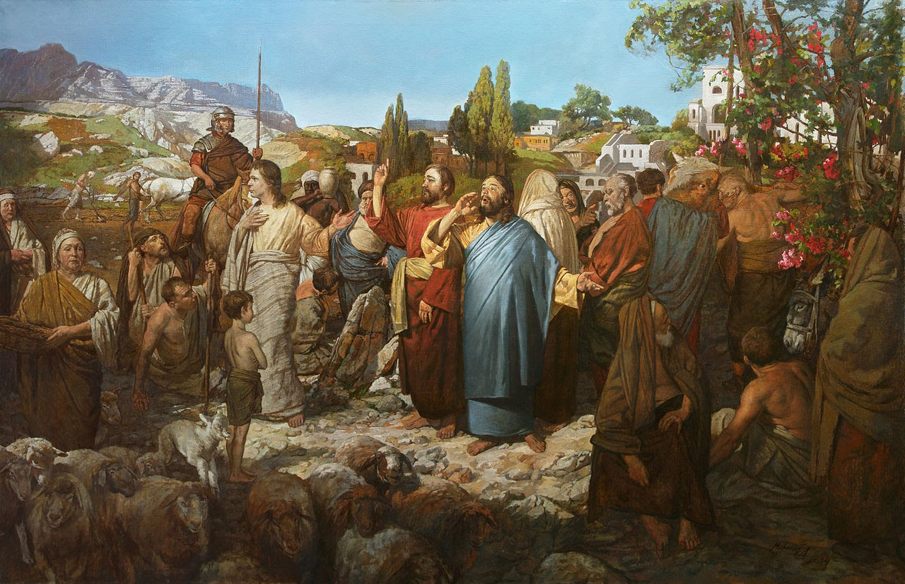

IMMACULATE CONCEPTION CATHOLIC CHURCH
506 COUNTY ROAD 1 - WEDOWEE, AL 36278
September 20, 2026
25th. Sunday in Ordinary Time
Reverend Gali Balaswamy gbalaswamy10@gmail.com 334-497-4847
Mass Times: Sunday English 10:30 am
Spanish: 12:00 pm
Friday Mass: Spanish: 6:00 pm
Sacrament of Reconciliation: Friday’s at 5:00 pm
Sunday’s at 11:30 am
Contact Information: Parish office: 256-357-2977
Email: immaculateconceptional@gmail.com
Website: Immaculateconceptional.org
Facebook: Immaculate Conception Catholic Church

Mission Statement: To enable ourselves and others to know, love and serve God the Father, Son and Holy Spirit. To participate in and provide the Sacraments. To promote spiritual growth and religious education and fellowship of the Catholic Church to all. To utilize the talents, leadership qualities and special skills given to us as a diversified parish family and to promote unity and develop closer relationships with other Christian faiths.

Pope's September Prayer Intention For the care of water -- Let us pray for a just and sustainable management of water, a vital resource, so that everyone may have equal access to it.

Weekly Mass Attendance: English 74 Spanish 162
Weekly Offerings
Weekly Collection: $ 996
Weekly Online $ $ 905
Building Fund: $ 970
Building Online: $ 132


ONLINE GIVING IS NOW AVAILABLE AT IMMACULATE CONCEPTION. Text to give is now available at Immaculate Conception. Just text the word “give” to 256-330-5544 and follow the links to set up a one time or recurring donation. Choose your convenient way to contribute either by text, online link https://giving.parishsoft.com/app/giving/icwedowee or QR Code Why not set up your recurring donation today and forget about writing checks. If anyone has any questions or needs help concerning any online giving options, feel free to contact Gerry Gettinger. 
ST. BLAISE HALL is available for small gatherings. Anyone wishing to use the hall for any reason MUST HAVE THEIR GATHERING PUT ON THE CHURCH CALENDAR. Contact Michele at variscom506@gmail.com or 678-481-0529
PRAY FOR THE SICK –Jim Betts, Ian Buchanan, Shirley & George Cervosky, Sarah Daly, Rita Agnes, Clay Stiner, Terri Dramis, Brent Hansen, Douglas Reiland, Dee Lohr

GUIDELINES FOR RECEPTION OF SACRAMENTS
BAPTISM: Contact Fredy Valasquez. He will set the date for Classes and confer with Fr Bala for a Baptismal Date. A minimum of 30 days, notice and completion of Baptismal preparation class and documentation must be completed before a date may be set.
MARRIAGE: Anyone planning a wedding must first contact Fr Bala. The guidelines set by the Diocese of B’ham state that one must contact the Pastor a minimum of 6 months prior to the selection of a date for the marriage. There are no exceptions.
FIRST HOLY COMMUNION: The youth must be in the second grade, older, and actively engaged in PSR for 2 or more years.
CONFIRMATION: The individual must be in the 7th grade, or older, and actively engaged in a two-year Confirmation preparation program.
QUINCEANERA: Individuals must contact Fr Bala at least 6 months prior to setting a date and begin a time of preparation to fully understand the significance of the celebration. There are no exceptions.

PARISH NEWS:

PARISH SCHOOL OF RELIGION CLASSES begin Saturday, September 19, 10:30 to 12:00 noon. If you have not signed up, please contact Michele.

OCTOBER LUNCHEON Sunday October 4th- The theme is “Autumn Harvest". An Email will be sent out soon with more details.

FOOD PANTRY If you would like to donate food to the Immaculate Conception Food Pantry, there is a list of needed items in the pantry. Monetary donations may also be made. Please remember that if you need food, whether you are Immaculate Conception parishioner or not, please contact Elvira Allende, 256 914-9645

DIOCESE NEWS
CATHOLIC CHARITIES ANNUAL APPEAL: Your support of this appeal brings Christ's love to those who are hurting, assist individuals and families in need, provide sacramental formation, and strengthen the faith of our Catholic community throughout North and Central Alabama. PLEDGE SUNDAY IS SUNDAY, SEPTEMBER 27, 2026. Pledge cards will be mailed to all registered parishioners and extra cards are available in the Narthex. The diocese has requested a goal of $6,600 for Immaculate Conception. Please prayerfully consider participating in this Catholic Charities annual appeal to help those who are hurting and lost find their way and remain in God's path.

As part of the Franciscan Jubilee Year, the Poor Clare of Perpetual Adoration will hold a commemoration of the Eighth Centenary of the passage of St. Francis of Assisi on Saturday, October 3 at the Shrine of the Most Blessed Sacrament in Hanceville, Ala. The event includes Mass, an EWTN television docudrama, the Sacrament of Confession, a recitation of the Franciscan Crown Rosary and the Transitus service. Father Joseph Mary, MFVA, is the featured speaker. Attendees can obtain a plenary indulgence by fulfilling the requirements set by the Holy See. For more information, please visit www.olamshrine.com/calendar.

PASTORAL MINISTRIES
Reverend Bala Balaswamy
Michele Varisco: Parish Council Chairperson
Email: variscom506@gmail.com Cell (678) 481-0529
Finance Council Chair: Jim Mitchell 678-717-7441 jtmitchell94@gmail.com
Hispanic Liaison: Exequiel Perez 256-276-8695

Sacristan: Alison & Nawana

SEPTEMBER MINISTERS SCHEDULE

Sunday, Sept. 20: Lector - Gerry Announcer - Erin
E.M. Helen
Usher: Tommy & Roger
Sunday, Sept. 27: Lector - Evelyn Announcer - Charlotte
E.M.: Roger
Usher: Frank & Tommy

Altar Linens 2026
September Cecilia
October Sandra
November Alison
December Bernardina

Church Cleaning Schedule:

September 19 - Galdino Velazquez & Family
Oct 3 – Pastor Lucero Group
Oct – 17 Fussell & Varisco
Oct 31 - Benedicto Gomez & Group
Nov 14 – Horacia/Bernadina & Baldomer/Hilaria
Nov 28 – Vincente/Elvira & Jose/Sandra

