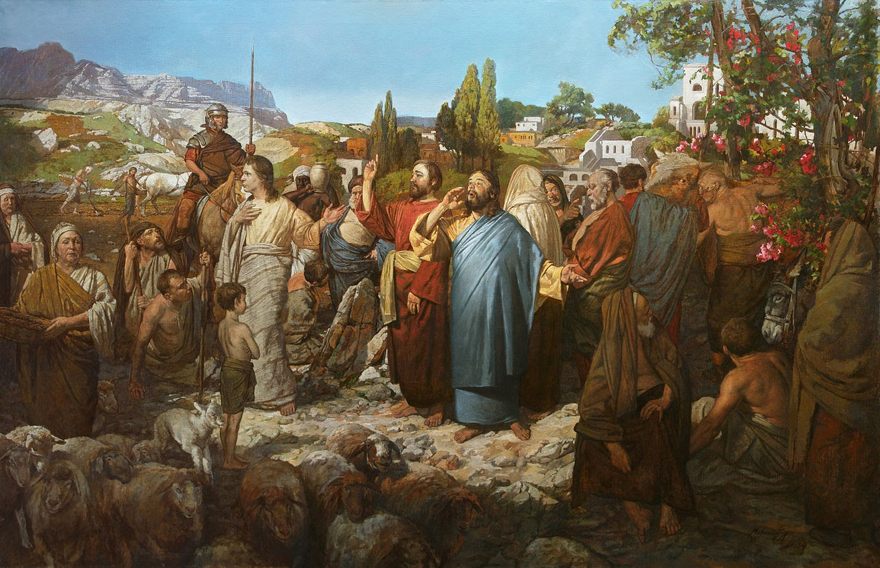

IMMACULATE CONCEPTION CATHOLIC CHURCH
506 COUNTY ROAD 1 - WEDOWEE, AL 36278
August 16, 2026
20th. Sunday in Ordinary Time
Reverend Gali Balaswamy gbalaswamy10@gmail.com 334-497-4847
Mass Times: Sunday English 10:30 am
Spanish: 12:00 pm
Friday Mass: Spanish: 6:00 pm
Sacrament of Reconciliation: Friday’s at 5:00 pm
Sunday’s at 11:30 am
Contact Information: Parish office: 256-357-2977
Email: immaculateconceptional@gmail.com
Website: Immaculateconceptional.org
Facebook: Immaculate Conception Catholic Church

Mission Statement: To enable ourselves and others to know, love and serve God the Father, Son and Holy Spirit. To participate in and provide the Sacraments. To promote spiritual growth and religious education and fellowship of the Catholic Church to all. To utilize the talents, leadership qualities and special skills given to us as a diversified parish family and to promote unity and develop closer relationships with other Christian faiths.

Pope's August Prayer Intention For Evangelization in the City -- Let us pray that in large cities often marked by anonymity and loneliness we find new ways to proclaim the Gospel, discovering creative paths to build community.

Weekly Mass Attendance: English 76 Spanish 142
Weekly Offerings
Weekly Collection: $ 1,642 Flowers $425 Candles $76
Weekly Online $ $ 332
Building Fund: $ 892
Building Online: $ 200


ONLINE GIVING IS NOW AVAILABLE AT IMMACULATE CONCEPTION. Text to give is now available at Immaculate Conception. Just text the word “give” to 256-330-5544 and follow the links to set up a one time or recurring donation. Choose your convenient way to contribute either by text, online link https://giving.parishsoft.com/app/giving/icwedowee or QR Code Why not set up your recurring donation today and forget about writing checks. If anyone has any questions or needs help concerning any online giving options, feel free to contact Gerry Gettinger. 
ST. BLAISE HALL is available for small gatherings. Anyone wishing to use the hall for any reason MUST HAVE THEIR GATHERING PUT ON THE CHURCH CALENDAR. Contact Michele at variscom506@gmail.com or 678-481-0529
PRAY FOR THE SICK –Jim Betts, Cass, Helen Betts, Ian Buchanan, Shirley & George Cervosky, Sarah Daly, Rita Agnes, Clay Stiner, Ellen, Terri Dramis

GUIDELINES FOR RECEPTION OF SACRAMENTS
BAPTISM: Contact Fredy Valasquez. He will set the date for Classes and confer with Fr Bala for a Baptismal Date. A minimum of 30 days, notice and completion of Baptismal preparation class and documentation must be completed before a date may be set.
MARRIAGE: Anyone planning a wedding must first contact Fr Bala. The guidelines set by the Diocese of B’ham state that one must contact the Pastor a minimum of 6 months prior to the selection of a date for the marriage. There are no exceptions.
FIRST HOLY COMMUNION: The youth must be in the second grade, older, and actively engaged in PSR for 2 or more years.
CONFIRMATION: The individual must be in the 7th grade, or older, and actively engaged in a two-year Confirmation preparation program.
QUINCEANERA: Individuals must contact Fr Bala at least 6 months prior to setting a date and begin a time of preparation to fully understand the significance of the celebration. There are no exceptions.

PARISH NEWS:

Authentic MEXICAN FOOD will be for sale after the 10:30 Mass Sunday, August 23. Please support this food sale. All proceeds are donated to Immaculate Conception.

YEAR OF ST. FRANCIS: Pope Leo designated this year to honor St. Francis of Assisi. We have had a beautiful poster of St. Francis in the church this year and we will begin singing hymns that are based on his teachings. We encourage everyone to join in singing.

MARRIAGE PREP classes are being formed. If you are planning a wedding within the next ten months, you will need to attend preparation classes. Please see Paul Dupuis or Michele for more information.

PARISH SCHOOL OF RELIGION CLASSES are being formed for all those who need instruction to receive the Sacraments. There is a sheet on the table in the Narthex. Please put your child's name along with the other information requested, including what Sacraments your child needs to receive.

KEEP CHRIST IN CHRISTMAS - Dennis from the Knights of Columbus will be in the parish hall Sunday, August 23, after both Masses selling Catholic Christmas items such as Christmas Rosaries, Christmas cards and other religious items. Please support the Knights of Columbus.

FEAST OF THE ASSUMPTION (a Holy Day of Obligation) will be celebrated Friday, August 14, at 6:00 p.m. This will be a bi-lingual Mass.

OCIA (Order of Christian Initiation) -- Do you or someone you know want to learn more about the Catholic Faith? Classes are being formed to instruct those wishing to begin the journey of faith into the teachings of the Catholic Church. Please see Paul Dupuis or Michele for more information.

FOOD PANTRY If you would like to donate food to the Immaculate Conception Food Pantry, there is a list of needed items in the pantry. Monetary donations may also be made. Please remember that if you need food, whether you are Immaculate Conception parishioner or not, please contact Elvira Allende, 256 914-9645

PASTORAL MINISTRIES
Reverend Bala Balaswamy
Michele Varisco: Parish Council Chairperson
Email: variscom506@gmail.com Cell (678) 481-0529
Finance Council Chair: Jim Mitchell 678-717-7441 jtmitchell94@gmail.com
Hispanic Liaison: Exequiel Perez 256-276-8695

Sacristan: Alison & Nawana

AUGUST MINISTERS SCHEDULE
Friday, Aug. 14 -- Lector: Bart
Usher: Roger & Diane
Sunday, Aug. 16 -- Lector: Brett Announcer: Evelyn
E.M.: Patty
Usher: Paul & Roger
Sunday, Aug. 23 -- Lector: Bart Announce: Michele
E.M.: Gerry
Usher: Diane & Tommy
Sunday, Aug. 30 -- Lector: Gerry Announce: Brett
E.M.: Paul
Usher: Frank & Michele

Altar Linens 2026
August Lioba
September Cecilia
October Sandra
November Alison
December Bernardina

Church Cleaning Schedule:
Aug. 22 - Cain/Broyles
September 5 - Juana Valezquez & Family
September 19 - Galdino Velazquez & Family
Oct 3 – Pastor Lucero Group
Oct – 17 Fussell & Varisco
Oct 31 - Benedicto Gomez & Group
Nov 14 – Horacia/Bernadina & Baldomer/Hilaria
Nov 28 – Vincente/Elvira & Jose/Sandra

