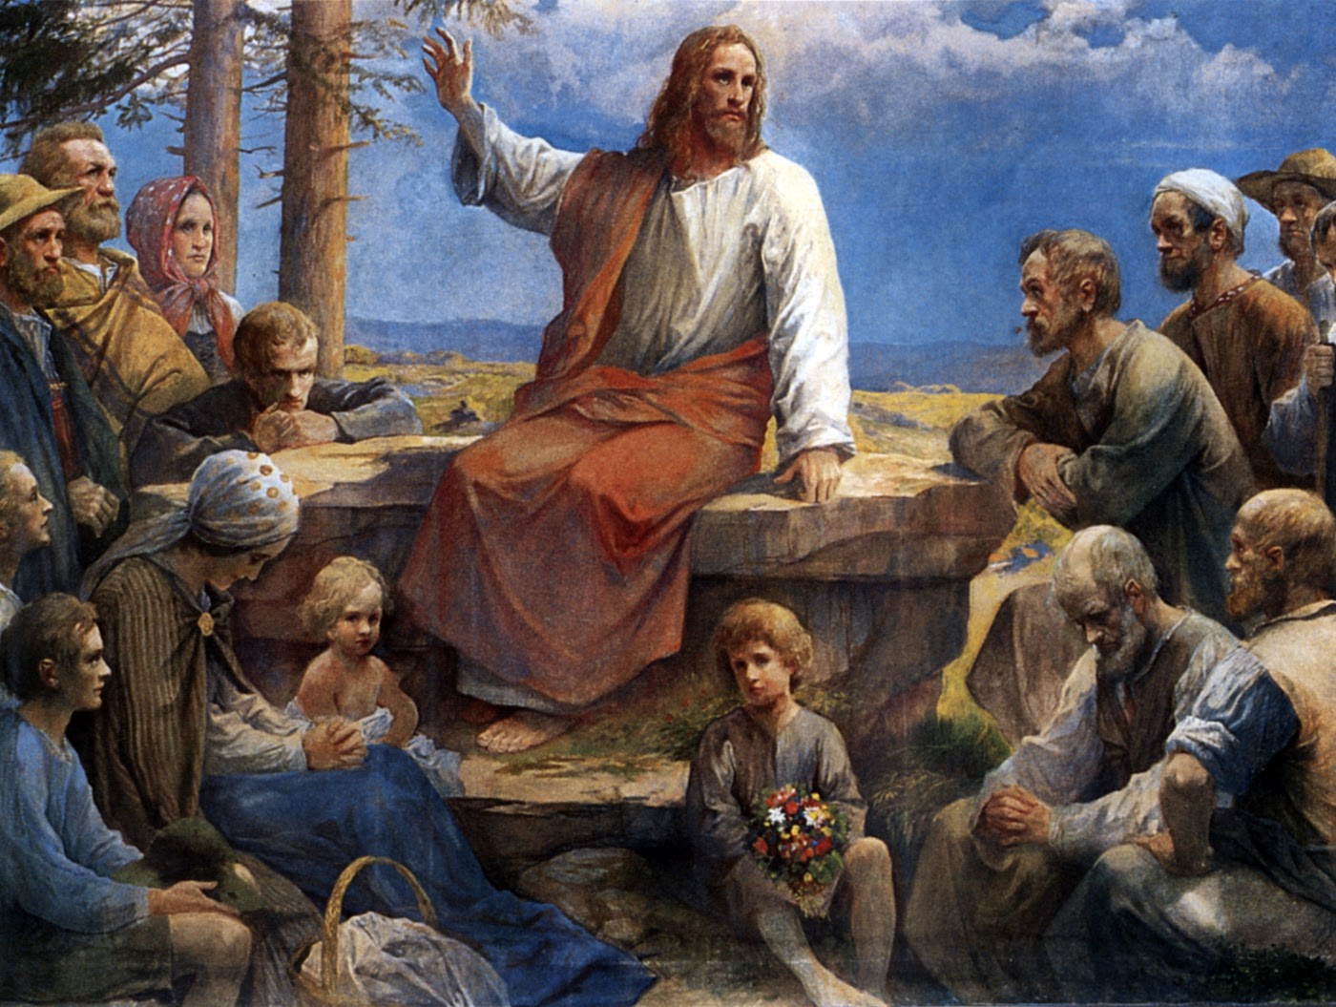

IMMACULATE CONCEPTION CATHOLIC CHURCH
506 COUNTY ROAD 1 - WEDOWEE, AL 36278
July 12, 2026
15th. Sunday in Ordinary Time
Reverend Gali Balaswamy gbalaswamy10@gmail.com 334-497-4847
Mass Times: Sunday English 10:30 am
Spanish: 12:00 pm
Friday Mass: Spanish: 6:00 pm
Sacrament of Reconciliation: Friday’s at 5:00 pm
Sunday’s at 11:30 am
Contact Information: Parish office: 256-357-2977
Email: immaculateconceptional@gmail.com
Website: Immaculateconceptional.org
Facebook: Immaculate Conception Catholic Church

Mission Statement: To enable ourselves and others to know, love and serve God the Father, Son and Holy Spirit. To participate in and provide the Sacraments. To promote spiritual growth and religious education and fellowship of the Catholic Church to all. To utilize the talents, leadership qualities and special skills given to us as a diversified parish family and to promote unity and develop closer relationships with other Christian faiths.

Pope's July Prayer Intention -- FOR RESPECT FOR HUMAN LIFE -- Let us pray for the respect and protection of human life in all its stages, recognizing it as a gift from God.

Weekly Mass Attendance: English 146 Spanish 132
Weekly Offerings
Weekly Collection: $ 1,787
Weekly Online $ $ 729
Building Fund: $ 595
Building Online: $ 864


ONLINE GIVING IS NOW AVAILABLE AT IMMACULATE CONCEPTION. Text to give is now available at Immaculate Conception. Just text the word “give” to 256-330-5544 and follow the links to set up a one time or recurring donation. Choose your convenient way to contribute either by text, online link https://giving.parishsoft.com/app/giving/icwedowee or QR Code Why not set up your recurring donation today and forget about writing checks. If anyone has any questions or needs help concerning any online giving options, feel free to contact Gerry Gettinger. 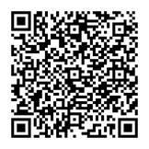
ST. BLAISE HALL is available for small gatherings. Anyone wishing to use the hall for any reason MUST HAVE THEIR GATHERING PUT ON THE CHURCH CALENDAR. Contact Michele at variscom506@gmail.com or 678-481-0529
PRAY FOR THE SICK –Jim Betts, Cass, Helen Betts, Ian Buchanan, Shirley & George Cervosky, Sarah Daly, Rita Agnes, Mary Cross, Trevor Kubie, Clay Stiner, Raylee Jones

GUIDELINES FOR RECEPTION OF SACRAMENTS
BAPTISM: Contact Fredy Valasquez. He will set the date for Classes and confer with Fr Bala for a Baptismal Date. A minimum of 30 days, notice and completion of Baptismal preparation class and documentation must be completed before a date may be set.
MARRIAGE: Anyone planning a wedding must first contact Fr Bala. The guidelines set by the Diocese of B’ham state that one must contact the Pastor a minimum of 6 months prior to the selection of a date for the marriage. There are no exceptions.
FIRST HOLY COMMUNION: The youth must be in the second grade, older, and actively engaged in PSR for 2 or more years.
CONFIRMATION: The individual must be in the 7th grade, or older, and actively engaged in a two-year Confirmation preparation program.
QUINCEANERA: Individuals must contact Fr Bala at least 6 months prior to setting a date and begin a time of preparation to fully understand the significance of the celebration. There are no exceptions.

PARISH NEWS:

SPECIAL COLLECTION FOR VENEZUELA NEXT SUNDAY, JULY 19 --The news reports of the devastating earthquakes in Venezuela call to mind once again our shared humanity and our privileged opportunity to assist our brothers and sisters in need. This special collection will help with the immediate crisis and recovery efforts. Thank you for your support.

ALTAR SERVER TRAINING: There is a sign up sheet in the Narthex for anyone who would like to be trained and become an Altar Server (the sheet is in Spanish, but please add your name/phone number and you will be contacted when training is scheduled.)

The next Ladies Bible Study will begin Wednesday, July 15. It will be a six week study entitled Psalms, praying with Jesus. We will meet at 9:30 in the hall. Please let Sharon know if you would like to attend so books can be ordered. Everyone is welcome,

FOOD PANTRY If you would like to donate food to the Immaculate Conception Food Pantry, there is a list of needed items in the pantry. Monetary donations may also be made. Please remember that if you need food, whether you are Immaculate Conception parishioner or not, please contact Elvira Allende, 256 914-9645

PASTORAL MINISTRIES
Reverend Bala Balaswamy
Michele Varisco: Parish Council Chairperson
Email: variscom506@gmail.com Cell (678) 481-0529
Finance Council Chair: Jim Mitchell 678-717-7441 jtmitchell94@gmail.com
Hispanic Liaison: Exequiel Perez 256-276-8695

Sacristan: Alison & Nawana

JUNE MINISTERS SCHEDULE
Sunday, July 12 - Lector: Charlotte Announcer Brett
E.M.: Pat
Usher: Tom & Frank
Sunday, July 19 - Lector: Bart Announcer: Gerry
E.M.: Patty L.
Usher: Diane & Paul
Sunday, July 26 - Lector: Erin Announcer: Evelyn
E.M.: Tommy
Usher: Frank & Roger

Altar Linens 2026
July Nawana
August Lioba
September Cecilia
October Sandra
November Alison
December Bernardina

Church Cleaning Schedule:
July 11 - Maguis/Flores
July 25 - Yessi/Vidales
Aug. 8 - Francisca Velasquez & Family
Aug. 22 - Cain/Broyles
September 5 - Juana Valezquez & Family
September 19 - Galdino Velazquez & Family

