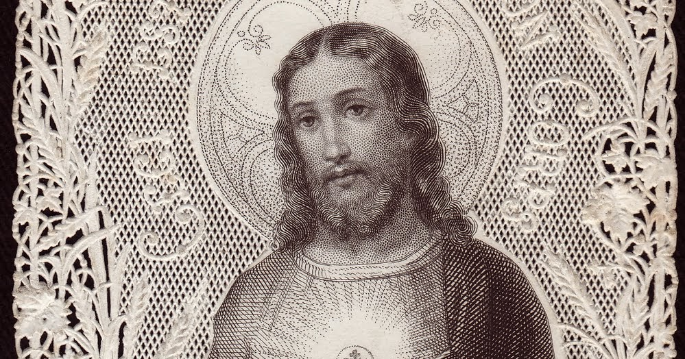

IMMACULATE CONCEPTION CATHOLIC CHURCH
506 COUNTY ROAD 1 - WEDOWEE, AL 36278
June 7, 2026
The Feast of Corpus Christi
Reverend Gali Balaswamy gbalaswamy10@gmail.com 334-497-4847
Mass Times: Sunday English 10:30 am
Spanish: 12:00 pm
Friday Mass: Spanish: 5:30 pm
Sacrament of Reconciliation: Friday’s at 5:00 pm
Sunday’s at 11:30 am
Contact Information: Parish office: 256-357-2977
Email: immaculateconceptional@gmail.com
Website: Immaculateconceptional.org
Facebook: Immaculate Conception Catholic Church

Mission Statement: To enable ourselves and others to know, love and serve God the Father, Son and Holy Spirit. To participate in and provide the Sacraments. To promote spiritual growth and religious education and fellowship of the Catholic Church to all. To utilize the talents, leadership qualities and special skills given to us as a diversified parish family and to promote unity and develop closer relationships with other Christian faiths.

Pope's June Prayer Intention --
For the values of sports -- Let us pray that sports be an instrument of peace, encounter, and dialogue among cultures and nations, and that they promote values such as respect, solidarity, and personal growth.

Weekly Mass Attendance: English 76 Spanish 173
Weekly Offerings
Weekly Collection: $ 1,757 Candles $51 Flowers $25
Weekly Online $ $ 1,000
Building Fund: $ 548
Building Online: $ 132


ONLINE GIVING IS NOW AVAILABLE AT IMMACULATE CONCEPTION. Text to give is now available at Immaculate Conception. Just text the word “give” to 256-330-5544 and follow the links to set up a one time or recurring donation. Choose your convenient way to contribute either by text, online link https://giving.parishsoft.com/app/giving/icwedowee or QR Code Why not set up your recurring donation today and forget about writing checks. If anyone has any questions or needs help concerning any online giving options, feel free to contact Gerry Gettinger. 
ST. BLAISE HALL is available for small gatherings. Anyone wishing to use the hall for any reason MUST HAVE THEIR GATHERING PUT ON THE CHURCH CALENDAR. Contact Michele at variscom506@gmail.com or 678-481-0529
PRAY FOR THE SICK –Jim Betts, Cass, Helen Betts, Ian Buchanan, Shirley & George Cervosky, Sharon Cain, Nawana Winkles, Sarah Daly, Rita Agnes, Mary Cross, Trevor Kubie, Clay Stiner

GUIDELINES FOR RECEPTION OF SACRAMENTS
BAPTISM: Contact Fredy Valasquez. He will set the date for Classes and confer with Fr Bala for a Baptismal Date. A minimum of 30 days, notice and completion of Baptismal preparation class and documentation must be completed before a date may be set.

MARRIAGE: Anyone planning a wedding must first contact Fr Bala. The guidelines set by the Diocese of B’ham state that one must contact the Pastor a minimum of 6 months prior to the selection of a date for the marriage. There are no exceptions.
FIRST HOLY COMMUNION: The youth must be in the second grade, older, and actively engaged in PSR for 2 or more years.
CONFIRMATION: The individual must be in the 7th grade, or older, and actively engaged in a two-year Confirmation preparation program.
QUINCEANERA: Individuals must contact Fr Bala at least 6 months prior to setting a date and begin a time of preparation to fully understand the significance of the celebration. There are no exceptions.

PARISH NEWS:

Rainforest Falls VBS was a huge success. 45 children attended and had a great time. A HUGE THANKS to all of our wonderful teens and adults who helped make this week possible by bringing bible stories to life, cooking meals, helping with crafts and games, of course, there is always the set up and clean up helpers. We couldn't have this wonderful experience for our children without all of you.

THE PARISH COUNCIL will meet Wednesday, June 10, 6:00 in St. Blaise Hall. All are welcome.

Fr. Bala will be celebrating Mass on Wednesday, June 10 at 5:00 followed by Adoration.

The next luncheon will be Sunday, June 7, after the 10:30 Mass. The theme is "Spring into Summer w/a lighter fare". An email with more information was sent out. If you have any questions, contact Kris Miller.

FOOD PANTRY If you would like to donate food to the Immaculate Conception Food Pantry, there is a list of needed items in the pantry. Monetary donations may also be made. Please remember that if you need food, whether you are Immaculate Conception parishioner or not, please contact Elvira Allende, 256 914-9645

PASTORAL MINISTRIES
Reverend Bala Balaswamy
Michele Varisco: Parish Council Chairperson
Email: variscom506@gmail.com Cell (678) 481-0529
Finance Council Chair: Jim Mitchell 678-717-7441 jtmitchell94@gmail.com
Hispanic Liaison: Exequiel Perez 256-276-8695

Sacristan: Alison & Nawana

JUNE MINISTERS SCHEDULE
Sunday, June 7 - Lector: Brett Announcer: Charlotte
E.M.: Tommy
Usher: Paul & Diane
Sunday, June 14 - Lector: Charlotte Announcer: Erin
E.M.: Paul
Usher: Roger & Frank
Sunday, June 21 - Lector: Evelyn Announcer: Brett
E.M.: Gerry
Usher: Tommy & Frank
Sunday, June 28 - Lector: Erin Announcer: Evelyn
E.M.: Helen
Usher: Roger & Gerry

Altar Linens 2026
June Elvira
July Nawana
August Lioba
September Cecilia
October Sandra
November Alison
December Bernardina

Church Cleaning Schedule:
June 13 - Vicente/Elvira/Jose Martin/Sandra
June 27 - Mitchell/Anker/Burke

