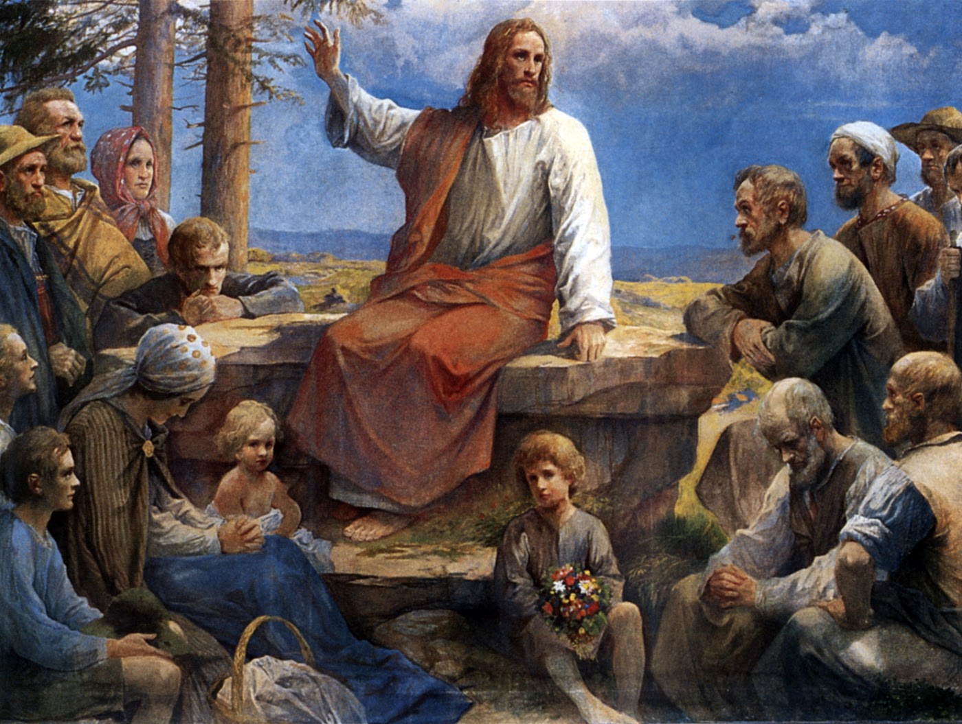

IMMACULATE CONCEPTION CATHOLIC CHURCH
506 COUNTY ROAD 1 - WEDOWEE, AL 36278
June 21, 2026
12th. Sunday in Ordinary Time
Reverend Gali Balaswamy gbalaswamy10@gmail.com 334-497-4847
Mass Times: Sunday English 10:30 am
Spanish: 12:00 pm
Friday Mass: Spanish: 5:30 pm
Sacrament of Reconciliation: Friday’s at 5:00 pm
Sunday’s at 11:30 am
Contact Information: Parish office: 256-357-2977
Email: immaculateconceptional@gmail.com
Website: Immaculateconceptional.org
Facebook: Immaculate Conception Catholic Church

Mission Statement: To enable ourselves and others to know, love and serve God the Father, Son and Holy Spirit. To participate in and provide the Sacraments. To promote spiritual growth and religious education and fellowship of the Catholic Church to all. To utilize the talents, leadership qualities and special skills given to us as a diversified parish family and to promote unity and develop closer relationships with other Christian faiths.

Pope's June Prayer Intention --
For the values of sports -- Let us pray that sports be an instrument of peace, encounter, and dialogue among cultures and nations, and that they promote values such as respect, solidarity, and personal growth.

We wish all our Fathers, Grandfathers and Father Bala a very Happy Father's Day.

Weekly Mass Attendance: English 74 Spanish 175
Weekly Offerings
Weekly Collection: $ 1,880 Candles $37
Weekly Online $ $ 455
Building Fund: $ 978
Building Online: $ 132


ONLINE GIVING IS NOW AVAILABLE AT IMMACULATE CONCEPTION. Text to give is now available at Immaculate Conception. Just text the word “give” to 256-330-5544 and follow the links to set up a one time or recurring donation. Choose your convenient way to contribute either by text, online link https://giving.parishsoft.com/app/giving/icwedowee or QR Code Why not set up your recurring donation today and forget about writing checks. If anyone has any questions or needs help concerning any online giving options, feel free to contact Gerry Gettinger. 
ST. BLAISE HALL is available for small gatherings. Anyone wishing to use the hall for any reason MUST HAVE THEIR GATHERING PUT ON THE CHURCH CALENDAR. Contact Michele at variscom506@gmail.com or 678-481-0529
PRAY FOR THE SICK –Jim Betts, Cass, Helen Betts, Ian Buchanan, Shirley & George Cervosky, Sarah Daly, Rita Agnes, Mary Cross, Trevor Kubie, Clay Stiner, Raylee Jones

GUIDELINES FOR RECEPTION OF SACRAMENTS
BAPTISM: Contact Fredy Valasquez. He will set the date for Classes and confer with Fr Bala for a Baptismal Date. A minimum of 30 days, notice and completion of Baptismal preparation class and documentation must be completed before a date may be set.
MARRIAGE: Anyone planning a wedding must first contact Fr Bala. The guidelines set by the Diocese of B’ham state that one must contact the Pastor a minimum of 6 months prior to the selection of a date for the marriage. There are no exceptions.
FIRST HOLY COMMUNION: The youth must be in the second grade, older, and actively engaged in PSR for 2 or more years.
CONFIRMATION: The individual must be in the 7th grade, or older, and actively engaged in a two-year Confirmation preparation program.
QUINCEANERA: Individuals must contact Fr Bala at least 6 months prior to setting a date and begin a time of preparation to fully understand the significance of the celebration. There are no exceptions.

PARISH NEWS:

SUNDAY, JUNE 28, there will be Authentic MEXICAN FOOD for sale after the 10:30 Mass. All proceeds will go to Immaculate Conception.

Please pray for the repose of the soul of Fred Monteil, brother of Helen Betts, who died last week.

There will be a special collection Sunday, June 21, for the Mission Cooperative Appeal. Your participation extends a hand of fellowship to foreign countries throughout the world and ensures that everyone knows that Christ leaves no one behind, nor does He forget anyone. Let us unite our efforts to make this year’s Mission Cooperative appeal a testament to our commitment to being missionary disciples. Your gifts echo the love and hospitality of the divine banquet to which we are all invited.

The next Ladies Bible Study will begin Wednesday, July 15. It will be a six week study entitled Psalms, praying with Jesus. We will meet at 9:30 in the hall. Please let Sharon know if you would like to attend so books can be ordered. Everyone is welcome,

FOOD PANTRY If you would like to donate food to the Immaculate Conception Food Pantry, there is a list of needed items in the pantry. Monetary donations may also be made. Please remember that if you need food, whether you are Immaculate Conception parishioner or not, please contact Elvira Allende, 256 914-9645

PASTORAL MINISTRIES
Reverend Bala Balaswamy
Michele Varisco: Parish Council Chairperson
Email: variscom506@gmail.com Cell (678) 481-0529
Finance Council Chair: Jim Mitchell 678-717-7441 jtmitchell94@gmail.com
Hispanic Liaison: Exequiel Perez 256-276-8695

Sacristan: Alison & Nawana

JUNE MINISTERS SCHEDULE

Sunday, June 21 - Lector: Evelyn Announcer: Brett
E.M.: Gerry
Usher: Tommy & Frank
Sunday, June 28 - Lector: Erin Announcer: Evelyn
E.M.: Helen
Usher: Roger & Gerry

Altar Linens 2026
June Elvira
July Nawana
August Lioba
September Cecilia
October Sandra
November Alison
December Bernardina

Church Cleaning Schedule:
June 27 - Mitchell/Anker/Burke
July 11 - Maguis/Flores
July 25 - Yessi/Vidales
Aug. 8 - Francisca Velasquez & Family
Aug. 22 - Cain/Broyles

