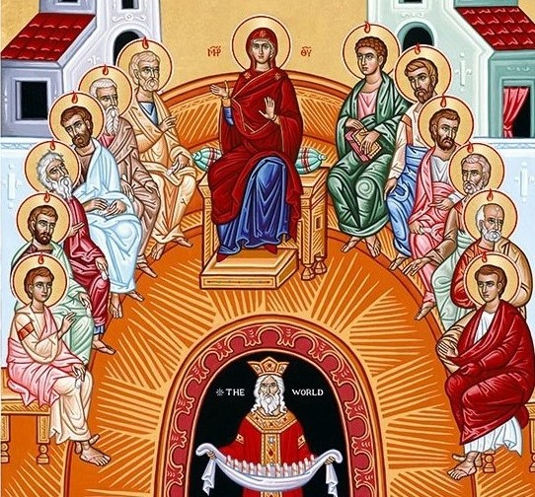

IMMACULATE CONCEPTION CATHOLIC CHURCH
506 COUNTY ROAD 1 - WEDOWEE, AL 36278
May 24, 2026
Pentecost Sunday
Reverend Gali Balaswamy gbalaswamy10@gmail.com 334-497-4847
Mass Times: Sunday English 10:30 am
Spanish: 12:00 pm
Friday Mass: Spanish: 5:30 pm
Sacrament of Reconciliation: Friday’s at 5:00 pm
Sunday’s at 11:30 am
Contact Information: Parish office: 256-357-2977
Email: immaculateconceptional@gmail.com
Website: Immaculateconceptional.org
Facebook: Immaculate Conception Catholic Church

Mission Statement: To enable ourselves and others to know, love and serve God the Father, Son and Holy Spirit. To participate in and provide the Sacraments. To promote spiritual growth and religious education and fellowship of the Catholic Church to all. To utilize the talents, leadership qualities and special skills given to us as a diversified parish family and to promote unity and develop closer relationships with other Christian faiths.

Pope's May Prayer Intention --
That everyone might have food. Let us pray that everyone, from large producers to small consumers, be committed to avoid wasting food, and to ensure that everyone has access to quality food.

PLEASE REMEMBER OUR BRAVE SERVICE MEMBERS WHO HAVE GIVEN THEIR LIFE FOR OUR FREEDOM!!

Wishing everyone a wonderful and safe Memorial Day Weekend!!

Weekly Mass Attendance: English 68 Spanish 154
Weekly Offerings
Weekly Collection: $ 1,271 Flower $100
Weekly Online $ $ 312
Building Fund: $ 490
Building Online: $ 132


ONLINE GIVING IS NOW AVAILABLE AT IMMACULATE CONCEPTION. Text to give is now available at Immaculate Conception. Just text the word “give” to 256-330-5544 and follow the links to set up a one time or recurring donation. Choose your convenient way to contribute either by text, online link https://giving.parishsoft.com/app/giving/icwedowee or QR Code Why not set up your recurring donation today and forget about writing checks. If anyone has any questions or needs help concerning any online giving options, feel free to contact Gerry Gettinger. 
ST. BLAISE HALL is available for small gatherings. Anyone wishing to use the hall for any reason MUST HAVE THEIR GATHERING PUT ON THE CHURCH CALENDAR. Contact Michele at variscom506@gmail.com or 678-481-0529
PRAY FOR THE SICK –Jim Betts, Cass, Helen Betts, Ian Buchanan, Shirley & George Cervosky, Sharon Cain, Nawana Winkles, Sarah Daly, Rita Agnes, Mary Cross

GUIDELINES FOR RECEPTION OF SACRAMENTS
BAPTISM: Contact Fredy Valasquez. He will set the date for Classes and confer with Fr Bala for a Baptismal Date. A minimum of 30 days, notice and completion of Baptismal preparation class and documentation must be completed before a date may be set.
MARRIAGE: Anyone planning a wedding must first contact Fr Bala. The guidelines set by the Diocese of B’ham state that one must contact the Pastor a minimum of 6 months prior to the selection of a date for the marriage. There are no exceptions.
FIRST HOLY COMMUNION: The youth must be in the second grade, older, and actively engaged in PSR for 2 or more years.
CONFIRMATION: The individual must be in the 7th grade, or older, and actively engaged in a two-year Confirmation preparation program.
QUINCEANERA: Individuals must contact Fr Bala at least 6 months prior to setting a date and begin a time of preparation to fully understand the significance of the celebration. There are no exceptions.

PARISH NEWS:

CONGRATULATIONS TO THE CLASS OF 2026 --
College: Diana Velasquez
High School: Patrick Bradley, Perla Escobar, Omar Antonio Valle, Edwin Morcelino, Alberto Torres Serafico, Oscar Vidales

VACATION BIBLE SCHOOL -- COME JOIN US FOR AN ADVENTURE TO RAINFOREST FALLS -- JUNE 2, 3, 4 -- 5:30 to 8:-00 p.m. Children ages 3 to 11 -- Sign up on the Rainforest Falls sheet in the Narthex.

The next luncheon will be Sunday, June 7, after the 10:30 Mass. The theme is "Spring into Summer w/a lighter fare". An email with more information was sent out. If you have any questions, contact Kris Miller.

FOOD PANTRY If you would like to donate food to the Immaculate Conception Food Pantry, there is a list of needed items in the pantry. Monetary donations may also be made. Please remember that if you need food, whether you are Immaculate Conception parishioner or not, please contact Elvira Allende, 256 914-9645

PASTORAL MINISTRIES
Reverend Bala Balaswamy
Michele Varisco: Parish Council Chairperson
Email: variscom506@gmail.com Cell (678) 481-0529
Finance Council Chair: Jim Mitchell 678-717-7441 jtmitchell94@gmail.com
Hispanic Liaison: Exequiel Perez 256-276-8695

Sacristan: Alison & Nawana

MAY MINISTERS SCHEDULE

Sunday, May 24 -- Lector: Charlotte Announcer: Michele
E.M.: Paul
Usher: Tommy & Gerry
Sunday, May 31 -- Lector: Evelyn Announcer: Erin
E.M.: Patty
Usher: Paul & Frank

Altar Linens 2026
May Alison
June Elvira
July Nawana
August Lioba
September Cecilia
October Sandra
November Alison
December Bernardina

Church Cleaning Schedule:

May 30 - Horacio/Bernadina, Baldomer/Hilaria
June 13 - Vicente/Elvira/Jose Martin/Sandra
June 27 - Mitchell/Anker/Burke

