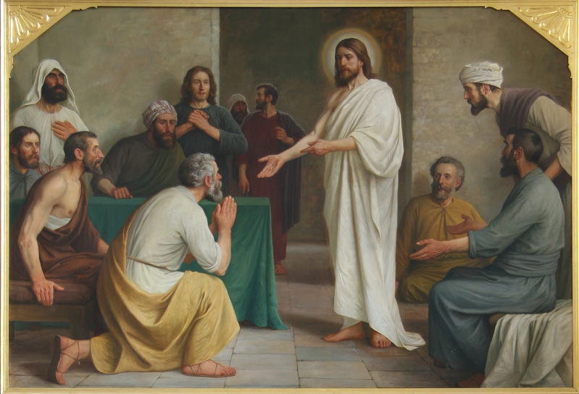

IMMACULATE CONCEPTION CATHOLIC CHURCH
506 COUNTY ROAD 1 - WEDOWEE, AL 36278
April 12, 2026
2nd Sunday of Easter
Reverend Gali Balaswamy gbalaswamy10@gmail.com 334-497-4847
Mass Times: Sunday English 10:30 am
Spanish: 12:00 pm
Friday Mass: Spanish: 5:30 pm
Sacrament of Reconciliation: Friday’s at 5:00 pm
Sunday’s at 11:30 am
Contact Information: Parish office: 256-357-2977
Email: immaculateconceptional@gmail.com
Website: Immaculateconceptional.org
Facebook: Immaculate Conception Catholic Church

Mission Statement: To enable ourselves and others to know, love and serve God the Father, Son and Holy Spirit. To participate in and provide the Sacraments. To promote spiritual growth and religious education and fellowship of the Catholic Church to all. To utilize the talents, leadership qualities and special skills given to us as a diversified parish family and to promote unity and develop closer relationships with other Christian faiths.

Pope's April Prayer Intention -- FOR PRIESTS IN CRISIS -- Let us pray for priests going through moments of crisis in their vocation, that they may find the accompaniment they need and that communities may support them with understanding and prayer. .

Weekly Mass Attendance: English 131 Spanish 206
Weekly Offerings
Weekly Collection: $ 2,425 Candles $65 Flowers $525 Food Pantry $2800
Weekly Online $ $ 918
Building Fund: $ 865
Building Online: $ 282
Holy Thursday $ 365

ONLINE GIVING IS NOW AVAILABLE AT IMMACULATE CONCEPTION. Text to give is now available at Immaculate Conception. Just text the word “give” to 256-330-5544 and follow the links to set up a one time or recurring donation. Choose your convenient way to contribute either by text, online link https://giving.parishsoft.com/app/giving/icwedowee or QR Code Why not set up your recurring donation today and forget about writing checks. If anyone has any questions or needs help concerning any online giving options, feel free to contact Gerry Gettinger. 
ST. BLAISE HALL is available for small gatherings. Anyone wishing to use the hall for any reason MUST HAVE THEIR GATHERING PUT ON THE CHURCH CALENDAR. Contact Michele at variscom506@gmail.com or 678-481-0529
PRAY FOR THE SICK –Jim Betts, Cass, Helen Betts, Ian Buchanan, Shirley & George Cervosky, Tommy Cain, Nawana Winkles, Sarah Daly
GUIDELINES FOR RECEPTION OF SACRAMENTS
BAPTISM: Contact Fredy Valasquez. He will set the date for Classes and confer with Fr Bala for a Baptismal Date. A minimum of 30 days, notice and completion of Baptismal preparation class and documentation must be completed before a date may be set.
MARRIAGE: Anyone planning a wedding must first contact Fr Bala. The guidelines set by the Diocese of B’ham state that one must contact the Pastor a minimum of 6 months prior to the selection of a date for the marriage. There are no exceptions.
FIRST HOLY COMMUNION: The youth must be in the second grade, older, and actively engaged in PSR for 2 or more years.
CONFIRMATION: The individual must be in the 7th grade, or older, and actively engaged in a two-year Confirmation preparation program.
QUINCEANERA: Individuals must contact Fr Bala at least 6 months prior to setting a date and begin a time of preparation to fully understand the significance of the celebration. There are no exceptions.

PARISH NEWS:
Next Sunday, April 12, is our annual Fiesta. There will only be ONE Mass next Sunday at 10:30 a.m. followed by fun and fellowship in St. Blaise Hall. The church will be providing the main meal, but we are asking everyone to help bring beverages, desserts and/or fruit. We hope to see everyone there.
EASTER FLOWER INTENTIONS
IN HONOR OF: The Walker Family, Sarah Daly, Nawana Winkles, U.S. Military, Jose Perez Family, Vicente Serafico Family, Laura Velazquez Family, Kevin Zuck, Anker Family
IN MEMORY OF: Hugh & Eleanor Ellis, Bryson & Frances Roberts, Leticia Salas Hernandez, Julio Velasquez, Bob Stone, Martin Garcia, Jose Luis Garcia, Chuck Smith, Bernard Cross, Gabriella Mejia, Leticia Hernandez Salas, Anacleto Lopez, Teresa Gonzales, Jeremiah Ezra Price, Martin Garcia Carrillo, Leticia Paguyo, Myrna Pascual, Florentina Matias, Roland Paguyo, Teodulo Matias, Ernie Nugent, Aurea Namangcayao, Lita Espoltero, Sylvia Espoltero, Maria Lopez Perez, Phyllis Grady, Louis Drocsch, Jerrodene Kerr, Raymond Kerr, Lewis Miller, Dr. Bill Evan

FOOD PANTRY If you would like to donate food to the Immaculate Conception Food Pantry, there is a list of needed items in the pantry. Monetary donations may also be made. Please remember that if you need food, whether you are Immaculate Conception parishioner or not, please contact Elvira Allende, 256 914-9645 or Stephanie Roberts, 256 276-8133, bedeh0426@gmail.com


PASTORAL MINISTRIES
Reverend Bala Balaswamy
Michele Varisco: Parish Council Chairperson
Email: variscom506@gmail.com Cell (678) 481-0529
Finance Council Chair: Jim Mitchell 678-717-7441 jtmitchell94@gmail.com
Hispanic Liaison: Exequiel Perez 256-276-8695

Sacristan: Alison & Nawana

APRIL MINISTERS SCHEDULE

Sunday, 4/12 - Lector Gerry Announcer: Bart
Usher: Frank & Tommy
Sunday, 4/19 - Lector: Evelyn Announcer: Charlotte
E.M.: Pat
Usher: Tom & Paul
Sunday, 4/26 - Lector: Chip Announcer: Brett
E.M.: Roger
Usher: Paul & Tommy

Altar Linens 2026
April Deysi
May Alison
June Elvira
July Nawana

Church Cleaning Schedule:
April 18 - Pastorlucero Group
May 2 - Fussell & Varisco
May 16 - Benedicto Gomez & group
May 30 - Horacio/Bernadina, Baldomer/Hilaria
June 13 - Vicente/Elvira/Jose Martin/Sandra
June 27 - Mitchell/Anker/Burke

