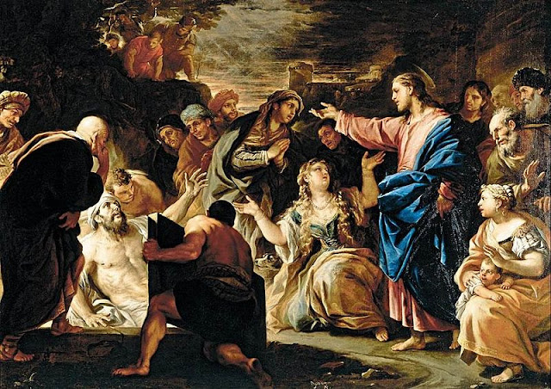

**IMMACULATE CONCEPTION CATHOLIC CHURCH**

**506 COUNTY ROAD 1 - WEDOWEE, AL 36278**

**April 6,, 2025**

**5th. Sunday in Lent**

**Reverend Gali** [**Balaswamy gbalaswamy10@gmail.com**](mailto:Balaswamy%20%20%20%20%20%20%20%20balaswmy10@gmail.com)334-497-4847

**Mass Times: Sunday English 10:30 am**

**Spanish: 12:00 pm**

**Friday Mass: Spanish: 6:00 pm**

**Sacrament of Reconciliation: Friday’s at 5:30 pm**

**Sunday’s at 11:30 am**

**Contact Information:** Parish office: 256-357-2977

Email: immaculateconceptional@gmail.com

Website: Immaculateconceptional.org

Facebook: Immaculate Conception Catholic Church

**Mission Statement:** *To enable ourselves and others to know, love and serve God the Father, Son and Holy Spirit. To participate in and provide the Sacraments. To promote spiritual growth and religious education and fellowship of the Catholic Church to all. To utilize the talents, leadership qualities and special skills given to us as a diversified parish family and to promote unity and develop closer relationships with other Christian faiths.*

**Pope's April Prayer Intention --** For the use of the new technologies --  Let us pray that the use of the new technologies will not replace human relationships, will respect the dignity of the person, and will help us face the crises of our times.

Weekly Mass Attendance: English 52 Spanish 167

**Weekly Offerings**

Weekly Collection: $ 766 Catholic Relief $423

Weekly Online: $ 314

Building Fund: $ 822

Building Online: $ 50



|  |
| --- |
|  |

**ONLINE GIVING IS NOW AVAILABLE AT IMMACULATE CONCEPTION. Text to give is now available at Immaculate Conception.** Just text the word “give” to 256-330-5544 and follow the links to set up a one time or recurring donation. Choose your convenient way to contribute either by text, online link https://giving.parishsoft.com/app/giving/icwedowee or QR Code Why not set up your recurring donation today and forget about writing checks. If anyone has any questions or needs help concerning any online giving options, feel free to contact Gerry Gettinger. Qr code

**ST. BLAISE HALL** is available for small gatherings. Anyone wishing to use the hall for any reason **MUST HAVE THEIR GATHERING PUT ON THE CHURCH CALENDAR**. Contact Michele at variscom506@gmail.com or 678-481-0529

**PRAY FOR THE SICK** –Bennett Lundy (grandson of Brett and Laurie Lundy), Chuck Smith, Jim Betts, Cass, Helen Betts, Marie Lettieri

**GUIDELINES FOR RECEPTION OF SACRAMENTS**

**BAPTISM:** Contact Maria Gembe. She will set the date for Classes and confer with Fr Bala for a Baptismal Date. A minimum of 30 days, notice and completion of Baptismal preparation class and documentation must be completed before a date may be set.

**MARRIAGE**: Anyone planning a wedding must first contact Fr Bala. The guidelines set by the Diocese of B’ham state that one must contact the Pastor a minimum of 6 months prior to the selection of a date for the marriage. There are no exceptions.

**FIRST HOLY COMMUNION**: The youth must be in the second grade, older, and actively engaged in PSR for 2 or more years.

**CONFIRMATION:** The individual must be in the 7th grade, or older, and actively engaged in a two-year Confirmation preparation program.

**QUINCEANERA:** Individuals must contact Fr Bala at least 6 months prior to setting a date and begin a time of preparation to fully understand the significance of the celebration. There are no exceptions.

**PARISH NEWS:**

***MARK YOUR CALENDARS*** -- Our annual ***FIESTA*** will be held Sunday, April 27.  There will only be one Mass that day at 10:30 followed by food and fellowship in the hall.  Please plan to attend.  More information will be coming soon.

***HOLY WEEK SCHEDULE***

April 13 - Palm Sunday -  10:30 English   12:00 Spanish

April 17 - Holy Thursday - Mass of The Lord's Supper - 6:45 p.m. Bi-lingual

                Adoration in the hall until 10:00 p.m.

April 18 - Good Friday - The Lord's Passion - 2:00 Stations of the Cross

                6:45 Bi-lingual Good Friday service

April 20 - Easter Sunday - The Resurrection of the Lord - 10:30 English and

                12:00 Spanish

***SEVEN LAST WORDS***:  Sacred Heart of Jesus Catholic Church, Anniston Al., will be having the service of **Seven Last Words** on Sunday, April 6 at 6:30 p.m.    Prelude music will begin at 6:10 p.m.  You are invited to attend this service of music, readings, silence and reflection.

Please consider making an ***EASTER FLOWER OFFERING*** to help defray the cost of decorating our church for Easter.  There are Flower Offering envelopes on the table in the Narthex and in your weekly collection envelope box.  You can designate on the envelope if you wish to have the flower offering in Memory of a loved one or in Honor of someone.  Once you have filled out the envelope, please put it in the regular collection basket or give it to one of the ushers.  Your intentions will be prayed for at the Masses during the Easter Season.  We appreciate your generosity and support.

The ***RANDOLPH COUNTY ANIMAL SHELTER BOOK SALE*** will take place Saturday, April 5 and April 12, 9 a.m. to 1 p.m. at the Old Cotton Warehouse across from Cedarwood Cemetery in Roanoke.  Books are $2 for hardback, $1 for paperbacks and Children’s books are 3 for $1. All proceeds go to the care of the animals at the shelter.  Plan to attend and support our county animal shelter.

Father Bala will be celebrating ***Mass this Wednesday, April 2 at 5:00*** followed by the Stations of the Cross.

**FOOD PANTRY** If you would like to donate food to the Immaculate Conception Food Pantr**y**, there is a list of needed items in the pantry. Monetary donations may also be made.Please remember that if you need food, whether you are Immaculate Conception parishioner or not, please contact Elvira Allende, 256 914-9645 or Stephanie Roberts, 256 276-8133, [bedeh0426@gmail.com](mailto:bedeh0426@gmail.com)

**PASTORAL MINISTRIES**

**Reverend Bala Balaswamy**

**Michele Varisco:** Parish Council Chairperson

Email: [variscom506@gmail.com](mailto:variscom506@gmail.com) Cell (678) 481-0529

**Tommy Cain:** Finance Council Chairperson

Email: [tcain8@bellsouth.net](mailto:tcain8@bellsouth.net) Cell (251) 454-8160

**Jim & Stephanie Roberts:** Building Committee

Email: [jim@multimetco.com](mailto:jim@multimetco.com)

**Anel Covarrubias:** Hispanic Liaison

Cell: (334) 863-1137

[anercovarrubias7@gmail.com](mailto:anercovarrubias7@gmail.com)

**APRIL MINISTER SCHEDULE**

Sunday, April 6 -  Lector: Brett     Announcer:  Gerry

                            E.M. Pat

                              Usher:  Paul & Tom

Sunday, April 13 - Lector:  Charlotte    announcer:  Michele

                              E.M.:  Roger

                              Usher:  Tommy & Frank

Thursday, April 17 - Lector:  Gerry

                                Usher:  Frank & Michele

Friday, April 18 -  Lector:  Chip   Announcer:  Michele

                                Usher:  Frank & Gerry (?)

Sunday, April 20 - Lector: Charlotte   Announcer:  Brett

                              E.M.:  Gerry

                              Usher:  Tommy & Chip

Sunday, April 27 (Parish Fiesta) - Lector:  Bart   Announcer:  Chip

                              E.M.  Roger

                              Usher:  Diane & Paul

**Sacristan:** Alison & Nawana

**Alter Linens 2025**

**April** Deysi

**May** Denise

**June**  Genoveva

**July** Chip

**August** Elvira

**September**  Cecilia

**October** Alison

**November**  Sandra

**December** Bernardina

**Church Cleaning Schedule:**

April 12 - Horacio/Bernadina & Baldomer/Hilaria

April 26 - Vicente/Elvira & Jose/Sandra

May 10 - Anker & Burke

May 24 - Francisca Velasquez & Family

June 7 -  Cain & Broyles

June 21 - Juana Velazquez & Family