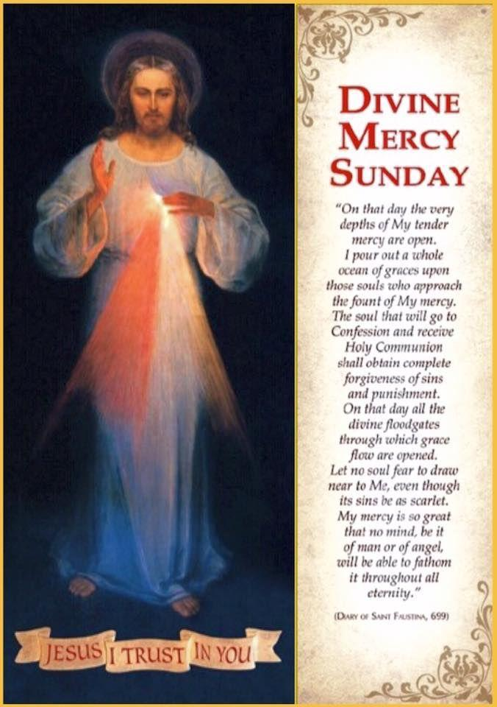

**IMMACULATE CONCEPTION CATHOLIC CHURCH**

**506 COUNTY ROAD 1 - WEDOWEE, AL 36278**

**April 27 2025**

**Divine Mercy Sunday**

**Reverend Gali** [**Balaswamy gbalaswamy10@gmail.com**](mailto:Balaswamy%20%20%20%20%20%20%20%20balaswmy10@gmail.com)334-497-4847

**Mass Times: Sunday English 10:30 am**

**Spanish: 12:00 pm**

**Friday Mass: Spanish: 6:00 pm**

**Sacrament of Reconciliation: Friday’s at 5:30 pm**

**Sunday’s at 11:30 am**

**Contact Information:** Parish office: 256-357-2977

Email: immaculateconceptional@gmail.com

Website: Immaculateconceptional.org

Facebook: Immaculate Conception Catholic Church

**Mission Statement:** *To enable ourselves and others to know, love and serve God the Father, Son and Holy Spirit. To participate in and provide the Sacraments. To promote spiritual growth and religious education and fellowship of the Catholic Church to all. To utilize the talents, leadership qualities and special skills given to us as a diversified parish family and to promote unity and develop closer relationships with other Christian faiths.*

***IN PRAYER FOR POPE FRANCIS --  Through the mercy of our Lord, may he rest in peace.***

***DIVINE MERCY SUNDAY***  celebrated on the second Sunday of Easter, is a feast day emphasizing God's boundless mercy and forgiveness.  In describing this feast , Saint Pope John Paul II says: "Divine Mercy!  This is the Easter gift that the Church receives from the risen Christ, a gift which it offers to all humanity."

**Pope's April Prayer Intention --** For the use of the new technologies --  Let us pray that the use of the new technologies will not replace human relationships, will respect the dignity of the person, and will help us face the crises of our times.

Weekly Mass Attendance: English 104 Spanish 163

**Weekly Offerings**

Weekly Collection: $ 1,656 Holy Thursday $182 Candles $49

Weekly Online: $ 420

Building Fund: $ 507

Building Online: $ 75



|  |
| --- |
|  |

**ONLINE GIVING IS NOW AVAILABLE AT IMMACULATE CONCEPTION. Text to give is now available at Immaculate Conception.** Just text the word “give” to 256-330-5544 and follow the links to set up a one time or recurring donation. Choose your convenient way to contribute either by text, online link https://giving.parishsoft.com/app/giving/icwedowee or QR Code Why not set up your recurring donation today and forget about writing checks. If anyone has any questions or needs help concerning any online giving options, feel free to contact Gerry Gettinger. Qr code

**ST. BLAISE HALL** is available for small gatherings. Anyone wishing to use the hall for any reason **MUST HAVE THEIR GATHERING PUT ON THE CHURCH CALENDAR**. Contact Michele at variscom506@gmail.com or 678-481-0529

**PRAY FOR THE SICK** –Bennett Lundy (grandson of Brett and Laurie Lundy), Chuck Smith, Jim Betts, Cass, Helen Betts, Patty Livingston, Joe Tedore, Deacon Lee Robinson

**GUIDELINES FOR RECEPTION OF SACRAMENTS**

**BAPTISM:** Contact Maria Gembe. She will set the date for Classes and confer with Fr Bala for a Baptismal Date. A minimum of 30 days, notice and completion of Baptismal preparation class and documentation must be completed before a date may be set.

**MARRIAGE**: Anyone planning a wedding must first contact Fr Bala. The guidelines set by the Diocese of B’ham state that one must contact the Pastor a minimum of 6 months prior to the selection of a date for the marriage. There are no exceptions.

**FIRST HOLY COMMUNION**: The youth must be in the second grade, older, and actively engaged in PSR for 2 or more years.

**CONFIRMATION:** The individual must be in the 7th grade, or older, and actively engaged in a two-year Confirmation preparation program.

**QUINCEANERA:** Individuals must contact Fr Bala at least 6 months prior to setting a date and begin a time of preparation to fully understand the significance of the celebration. There are no exceptions.

**PARISH NEWS:**

***DIVINE MERCY SUNDAY***  celebrated on the second Sunday of Easter, is a feast day emphasizing God's boundless mercy and forgiveness.  In describing this feast , Saint Pope John Paul II says: "Divine Mercy!  This is the Easter gift that the Church receives from the risen Christ, a gift which it offers to all humanity."

**Calling all ladies of the Parish** --  Please join us on Wednesday mornings at 9:30 a.m. in St. Blaise Hall for **BIBLE STUDY**.  We will be looking at The Acts of the Apostles for the next six weeks.

Our **A*nnual FIESTA*** will be held ***Sunday, April 27.***

There will only be **one Mass** that day at 10:30 followed by food and fellowship in the hall.  The main meal will be provided.  We are asking English parishioners to bring Desserts, Lemonade and/or Iced Tea and the Spanish parishioners to bring fruit, bottled water and Orange Juice.  ***WEAR YOUR IMMACULATE CONCEPTION SHIRT*** if you have one.  Please join us for this annual event.

**FOOD PANTRY** If you would like to donate food to the Immaculate Conception Food Pantr**y**, there is a list of needed items in the pantry. Monetary donations may also be made.Please remember that if you need food, whether you are Immaculate Conception parishioner or not, please contact Elvira Allende, 256 914-9645 or Stephanie Roberts, 256 276-8133, [bedeh0426@gmail.com](mailto:bedeh0426@gmail.com)

***EASTER FLOWER INTENTIONS:***

**IN HONOR OF:**  U.S. Military, Israel Velasquez & Family, Walker Family, Nugent Family, Kelly Barber, Zuck Family, Bennett Lundy, Emeli Velasquez & Family, Rumaldo Velasquez & Family, Augustina Velasquez & Family

**IN MEMORY OF:**  Mary Pool, Roland Paguyo, Florentina Matias, Teodulo Matias Sr., Teodulo Matias Jr., Norma Matias, Jerrodene Kerr, Raymond Kerr, Lewis Miller, Sandy Carpenter, Bob Carpenter, Steven Butcher, Marian Lundy, Francis & Bryson Roberts, Hugh & Eleanor Ellis, Martin Gracia Carrillo, Martin Carrillo, Fred & Elaine Reiland, Frank & Dorothy Varisco, Ernie Nugent, Hiram Massengale, Lula Mae Sheppard, Sam Cantrell, Mary Cantrell, Daniel Winkles, Bill Cantrell, JoAnn Cantrell

**PASTORAL MINISTRIES**

**Reverend Bala Balaswamy**

**Michele Varisco:** Parish Council Chairperson

Email: [variscom506@gmail.com](mailto:variscom506@gmail.com) Cell (678) 481-0529

**Tommy Cain:** Finance Council Chairperson

Email: [tcain8@bellsouth.net](mailto:tcain8@bellsouth.net) Cell (251) 454-8160

**Jim & Stephanie Roberts:** Building Committee

Email: [jim@multimetco.com](mailto:jim@multimetco.com)

**Anel Covarrubias:** Hispanic Liaison

Cell: (334) 863-1137

[anercovarrubias7@gmail.com](mailto:anercovarrubias7@gmail.com)

**APRIL MINISTER SCHEDULE**

Sunday, April 27 (Parish Fiesta) - Lector:  Bart   Announcer:  Chip

                              E.M.  Roger

                              Usher:  Diane & Paul

**Sacristan:** Alison & Nawana

**Alter Linens 2025**

**April** Deysi

**May** Denise

**June**  Genoveva

**July** Chip

**August** Elvira

**September**  Cecilia

**October** Alison

**November**  Sandra

**December** Bernardina

**Church Cleaning Schedule:**

April 26 - Vicente/Elvira & Jose/Sandra

May 10 - Anker & Burke & Mitchell

May 24 - Francisca Velasquez & Family

June 7 -  Cain & Broyles

June 21 - Juana Velazquez & Family

