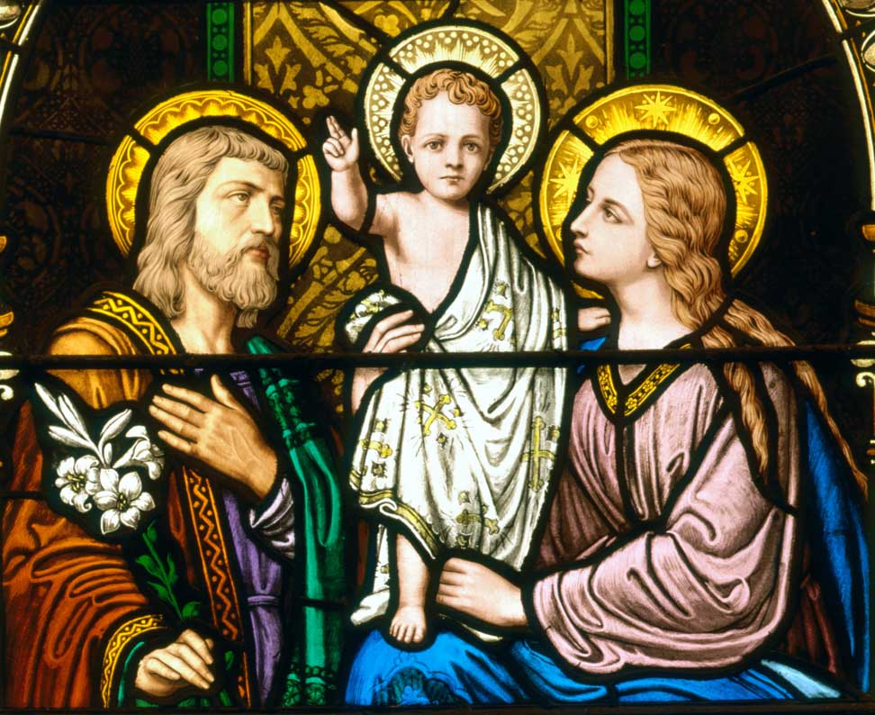

**IMMACULATE CONCEPTION CATHOLIC CHURCH**

**506 COUNTY ROAD 1 - WEDOWEE, AL 36278**

**January 5, 2025**

**Feast of the Epiphany of the Lord**

**Reverend Gali** [**Balaswamy gbalaswamy10@gmail.com**](mailto:Balaswamy%20%20%20%20%20%20%20%20balaswmy10@gmail.com)334-497-4847

**Mass Times: Sunday English 10:30 am**

**Spanish: 12:00 pm**

**Friday Mass: Spanish: 5:30 pm**

**Sacrament of Reconciliation: Friday’s at 5:30 pm**

**Sunday’s at 11:30 am**

**Contact Information:** Parish office: 256-357-2977

Email: immaculateconceptional@gmail.com

Website: Immaculateconceptional.org

Facebook: Immaculate Conception Catholic Church

**Mission Statement:** *To enable ourselves and others to know, love and serve God the Father, Son and Holy Spirit. To participate in and provide the Sacraments. To promote spiritual growth and religious education and fellowship of the Catholic Church to all. To utilize the talents, leadership qualities and special skills given to us as a diversified parish family and to promote unity and develop closer relationships with other Christian faiths.*

**Pope's January Prayer Intention:**  For the right to an education --  Let us pray for migrants, refugees, and those affected by war, that their right to an education, which is necessary to build a better world, might always be respected.

**BEST WISHES TO EVERYONE FOR A VERY BLESSED, HEALTHY AND HAPPY NEW YEAR!!!**

.

Weekly Mass Attendance: English 92 Spanish 130

**Weekly Offerings**

Weekly Collection: $ 756 Flowers $10 -- Christmas $625

Weekly Online: $ 279.00

Building Fund: $ 411.00

Building Online: $



|  |
| --- |
|  |

**ONLINE GIVING IS NOW AVAILABLE AT IMMACULATE CONCEPTION. Text to give is now available at Immaculate Conception.** Just text the word “give” to 256-330-5544 and follow the links to set up a one time or recurring donation. Choose your convenient way to contribute either by text, online link https://giving.parishsoft.com/app/giving/icwedowee or QR Code Why not set up your recurring donation today and forget about writing checks. If anyone has any questions or needs help concerning any online giving options, feel free to contact Gerry Gettinger. Qr code

**ST. BLAISE HALL** is available for small gatherings. Anyone wishing to use the hall for any reason **MUST HAVE THEIR GATHERING PUT ON THE CHURCH CALENDAR**. Contact Michele at variscom506@gmail.com or 678-481-0529

**PRAY FOR THE SICK** –Bennett Lundy (grandson of Brett and Laurie Lundy), Chuck Smith, Patti Livingston, Jim Betts, Lanelle Cova, Cass, Mike Cova, Helen Betts, Nawana Winkles

**GUIDELINES FOR RECEPTION OF SACRAMENTS**

**BAPTISM:** Contact Maria Gembe. She will set the date for Classes and confer with Fr Bala for a Baptismal Date. A minimum of 30 days, notice and completion of Baptismal preparation class and documentation must be completed before a date may be set.

**MARRIAGE**: Anyone planning a wedding must first contact Fr Bala. The guidelines set by the Diocese of B’ham state that one must contact the Pastor a minimum of 6 months prior to the selection of a date for the marriage. There are no exceptions.

**FIRST HOLY COMMUNION**: The youth must be in the second grade, older, and actively engaged in PSR for 2 or more years.

**CONFIRMATION:** The individual must be in the 7th grade, or older, and actively engaged in a two-year Confirmation preparation program.

**QUINCEANERA:** Individuals must contact Fr Bala at least 6 months prior to setting a date and begin a time of preparation to fully understand the significance of the celebration. There are no exceptions.

**PARISH NEWS:**

The next Parish Council meeting will be Wednesday, January 8, at 6:00.  Everyone is welcome.

Father Bala will be going home to India for a visit.  He will be leaving January 8.  Be sure to wish him safe travels and a wonderful visit with his family.  Father Daniel Stack will be celebrating Masses for us while Fr. Bala is gone.  **THERE WILL BE NO FRIDAY MASSES JANUARY 10, 17, 24, 31 AND FEBRUARY 7 & 14**

**NO MASS ON Friday December 27, Fr. Bala will be out of town.**

***CHRISTMAS FLOWER PRAYER INTENTIONS***

***IN HONOR OF:***  U.S. Military, Cain Family, Zuck 30th Anniversary, Rumaldo Velazquez Family

***IN MEMORY OF:***  Nancy Hopkins, Jerrodene Kerr, Raymond Kerr, Lewis Miller, Leslie Stanley, Ed Vielhaber, Burke Family, Tolentino Family, Beatrice Laverick, Michael Laverick, Amarante Chavez, Gabriella Mejia, Letecia Salas, Anadeto Lopez, Teresa Godinez, Julio Velasquez, Bryson Roberts, France Roberts, Hugh Ellis, Eleanor Ellis, Albert Gregg, Frank & Dorothy Varisco, Fred & Elaine Reiland, Roland Paguyo, Louise Pool, Sandra Graham, Ernie Nugent

**FOOD PANTRY** If you would like to donate food to the Immaculate Conception Food Pantr**y**, there is a list of needed items in the pantry. Monetary donations may also be made.Please remember that if you need food, whether you are Immaculate Conception parishioner or not, please contact Elvira Allende, 256 914-9645 or Stephanie Roberts, 256 276-8133, [bedeh0426@gmail.com](mailto:bedeh0426@gmail.com)

**PASTORAL MINISTRIES**

**Reverend Bala Balaswamy**

**Michele Varisco:** Parish Council Chairperson

Email: [variscom506@gmail.com](mailto:variscom506@gmail.com) Cell (678) 481-0529

**Tommy Cain:** Finance Council Chairperson

Email: [tcain8@bellsouth.net](mailto:tcain8@bellsouth.net) Cell (251) 454-8160

**Jim & Stephanie Roberts:** Building Committee

Email: [jim@multimetco.com](mailto:jim@multimetco.com)

**Anel Covarrubias:** Hispanic Liaison

Cell: (334) 863-1137

[anercovarrubias7@gmail.com](mailto:anercovarrubias7@gmail.com)

**JANUARY MINISTER SCHEDULE**

January 5 -  Lector:  Charlotte      Announcer:  Brett

                    E.M.:  Helen

                    Usher:  Tommy & Roger

January 12 -  Lector:  Chip     Announcer:  Michele

                      E.M.:  Pat

                      Usher:  Tom & Paul

January 19 - Lector:  Bart     Announcer:  Charlotte

                     E.M.:  Tommy

                     Usher:  Diane  & Frank

January 26 -  Lector:  Brett         Announcer:  Gerry

                     E.M.:  Roger

                     Usher:  Paul & Frank

**Sacristan:** Alison & Nawana

**Alter Linens 2025**

**Church Cleaning Schedule:**

January 4, 2025 - Francisca Velazquez & Family

January 18, 2025 - Cain & Broyles

February 1 - Juan Velasquez & Family

February 15 - Galdino Velazquez & Family