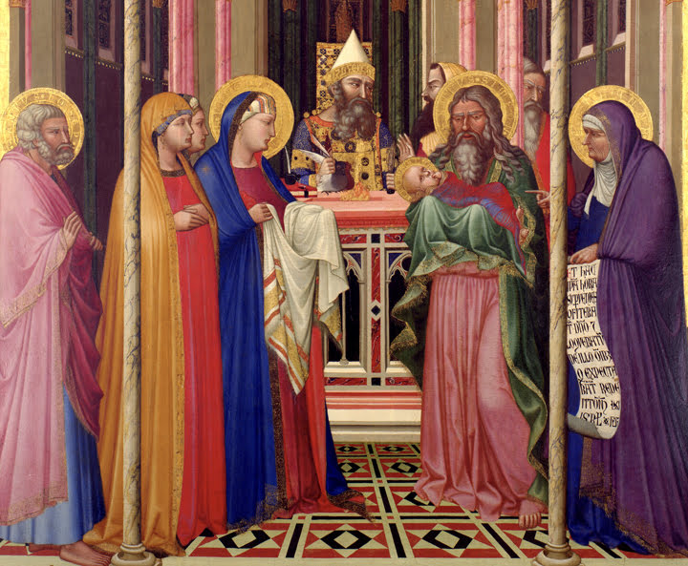

**IMMACULATE CONCEPTION CATHOLIC CHURCH**

**506 COUNTY ROAD 1 - WEDOWEE, AL 36278**

**February 2, 2025**

**Presentation of the Lord**

**Reverend Gali** [**Balaswamy gbalaswamy10@gmail.com**](mailto:Balaswamy%20%20%20%20%20%20%20%20balaswmy10@gmail.com)334-497-4847

**Mass Times: Sunday English 10:30 am**

**Spanish: 12:00 pm**

**Friday Mass: Spanish: 5:30 pm**

**Sacrament of Reconciliation: Friday’s at 5:30 pm**

**Sunday’s at 11:30 am**

**Contact Information:** Parish office: 256-357-2977

Email: immaculateconceptional@gmail.com

Website: Immaculateconceptional.org

Facebook: Immaculate Conception Catholic Church

**Mission Statement:** *To enable ourselves and others to know, love and serve God the Father, Son and Holy Spirit. To participate in and provide the Sacraments. To promote spiritual growth and religious education and fellowship of the Catholic Church to all. To utilize the talents, leadership qualities and special skills given to us as a diversified parish family and to promote unity and develop closer relationships with other Christian faiths.*

**POPE'S FEBRUARY PRAYER INTENTION** -- For Vocations to the Priesthood and Religious Life - Let us pray that the ecclesial community might welcome the desires and doubts of those young people who feel a call to serve Christ's mission in the priesthood and religious life.

Weekly Mass Attendance: English 64 Spanish 157

**Weekly Offerings**

Weekly Collection: $ 1,530 Candles $51

Weekly Online: $ 237.50

Building Fund: $ 724.00

Building Online: $ 41.50



|  |
| --- |
|  |

**ONLINE GIVING IS NOW AVAILABLE AT IMMACULATE CONCEPTION. Text to give is now available at Immaculate Conception.** Just text the word “give” to 256-330-5544 and follow the links to set up a one time or recurring donation. Choose your convenient way to contribute either by text, online link https://giving.parishsoft.com/app/giving/icwedowee or QR Code Why not set up your recurring donation today and forget about writing checks. If anyone has any questions or needs help concerning any online giving options, feel free to contact Gerry Gettinger. Qr code

**ST. BLAISE HALL** is available for small gatherings. Anyone wishing to use the hall for any reason **MUST HAVE THEIR GATHERING PUT ON THE CHURCH CALENDAR**. Contact Michele at variscom506@gmail.com or 678-481-0529

**PRAY FOR THE SICK** –Bennett Lundy (grandson of Brett and Laurie Lundy), Chuck Smith, Jim Betts, Lanelle Cova, Cass, Mike Cova, Helen Betts, Nawana Winkles, Joe and Marie Lettieri, Phylis Grady

**GUIDELINES FOR RECEPTION OF SACRAMENTS**

**BAPTISM:** Contact Maria Gembe. She will set the date for Classes and confer with Fr Bala for a Baptismal Date. A minimum of 30 days, notice and completion of Baptismal preparation class and documentation must be completed before a date may be set.

**MARRIAGE**: Anyone planning a wedding must first contact Fr Bala. The guidelines set by the Diocese of B’ham state that one must contact the Pastor a minimum of 6 months prior to the selection of a date for the marriage. There are no exceptions.

**FIRST HOLY COMMUNION**: The youth must be in the second grade, older, and actively engaged in PSR for 2 or more years.

**CONFIRMATION:** The individual must be in the 7th grade, or older, and actively engaged in a two-year Confirmation preparation program.

**QUINCEANERA:** Individuals must contact Fr Bala at least 6 months prior to setting a date and begin a time of preparation to fully understand the significance of the celebration. There are no exceptions.

**PARISH NEWS:**

**THE FEAST OF ST. BLAISE.**  Father Daniel will Bless throats at Mass on February 2, for all those who would like their throats, Blessed.

Your **2024 IC contribution letters** will be mailed out by the end of January. Once you receive them if you have any questions or need more details concerning your contributions please contact Gerry Gettinger.

Our next Luncheon will be **SUNDAY, FEBRUARY 2,** after the 10:30 Mass. It will be a tailgate theme. There will be a Super Bowl Pool available for anyone wanting to participate. Each square is $1. An email went out with more information.  Please respond by January 29 if you plan to attend.

The Parish Council will meet Wednesday, February 12, at 6:00 in the Parish Hall.  All are welcome to attend.

**FOOD PANTRY** If you would like to donate food to the Immaculate Conception Food Pantr**y**, there is a list of needed items in the pantry. Monetary donations may also be made.Please remember that if you need food, whether you are Immaculate Conception parishioner or not, please contact Elvira Allende, 256 914-9645 or Stephanie Roberts, 256 276-8133, [bedeh0426@gmail.com](mailto:bedeh0426@gmail.com)

***EUCHARISTIC MIRACLES:***  In the entire history of the Catholic Church, there have been numerous Eucharistic Miracles approved by the Catholic Church as truly worthy of belief.  The Vatican Eucharistic Miracles Photographic Exhibition faithfully recounts many well-documented miraculous occurrences for us.  Knowledge of these miracles strengthens our faith in Christ and His Church.  They are visible proof of Jesus Christ's Real Presence in the Holy Eucharist.  The Exhibit will be available for viewing at St. John the Apostle Catholic Church in Alexander City, Alabama, February 20-23, 2025.  You are encouraged to travel to 454 N. Central Avenue, Alexander City to view the exhibit during this year of Eucharistic Renewal.

Oral Presentation Times

Thursday, February 20, 2025 – 9:00 am, 11:00 am, 1:00 pm, 6:00 pm

Friday, February 21, 2025 - 9:00 am, 11:00 am, 1:00 pm, 6:00 pm

Saturday, February 22, 2025 - 9:00 am, 11:00 am, 1:00 pm, 6:00 pm

Sunday, February 23, 2025 – Displays Only

***JUBILEE YEAR:***  2025 is a Jubilee Year which is a special year of grace and reconciliation.  The Catholic Church celebrates a Jubilee Year every 25 years.  There are a number of ways in which Catholics can participate in the Jubilee year.  The most traditional observance is making a pilgrimage, as pilgrimages are emblematic of our life's journey toward God.  A key symbol of the Jubilee is the holy door which reminds us of Jesus' saying in the Gospel of John: "I am the gate. Whoever enters through me will be saved, and will come in and go out and find pasture"  Another major part of the Jubilee Year is the special opportunities to earn indulgences.  An indulgence is "the remission in the sight of God of the temporal punishment due for sins, the guilt of which has already been forgiven.

**PASTORAL MINISTRIES**

**Reverend Bala Balaswamy**

**Michele Varisco:** Parish Council Chairperson

Email: [variscom506@gmail.com](mailto:variscom506@gmail.com) Cell (678) 481-0529

**Tommy Cain:** Finance Council Chairperson

Email: [tcain8@bellsouth.net](mailto:tcain8@bellsouth.net) Cell (251) 454-8160

**Jim & Stephanie Roberts:** Building Committee

Email: [jim@multimetco.com](mailto:jim@multimetco.com)

**Anel Covarrubias:** Hispanic Liaison

Cell: (334) 863-1137

[anercovarrubias7@gmail.com](mailto:anercovarrubias7@gmail.com)

**FEBURARY MINISTER SCHEDULE**

Feb. 2 -- Lector:  Chip    Announcer:  Brett

                E.M.:  Nawana

                Usher:  Paul & Tommy

Feb. 9 -- Lector:  Bart    Announcer:  Gerry

                E.M.:  Pat

                Usher:  Tom & Diane

Feb. 16 -- Lector:  Brett    Announcer:  Chip

                  E.M.:  Gerry

                  Usher:  Paul & Frank

Feb. 23 --  Lector:  Charlotte    Announcer:  Michele

                  E.M.:  Patty Livingston

                  Usher:  Roger & Tommy

**Sacristan:** Alison & Nawana

**Alter Linens 2025**

**February** Lioba

**March** Nawana

**April** Deysi

**May** Denise

**June**  Genoveva

**July** Chip

**August** Elvira

**September**  Cecilia

**October** Alison

**November**  Sandra

**December** Bernardina

**Church Cleaning Schedule:**

February 1 - Juan Velasquez & Family

February 15 - Galdino Velazquez & Family

March 1 - Marlen & Friends/Family

March 15 – Varisco & Fussell

March 29 – Sandra Zacarias & Family